**USING RAPTOR –DISPLAY LENGTH OF STRING**

**T. SUMANTH**

**192011452**

**FLOWCHART**

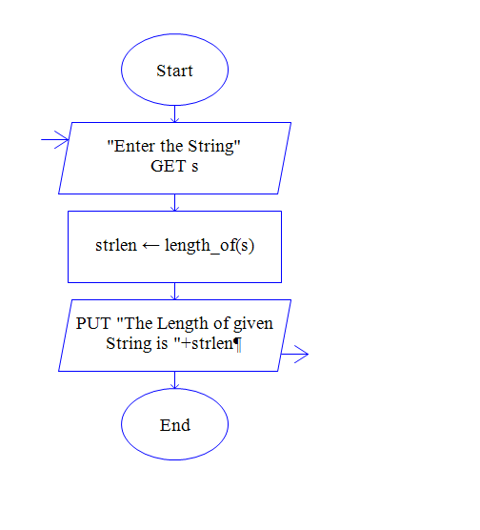

**INPUT**

**SAVEETHASCHOOLOF ENGINEERING**

**OUTPUT**

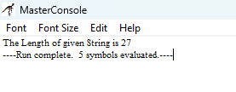**RESULT:**

The program is executed and verified successfully